Database Design Final Project
  - Cellular Towers in PA
By Hannah Jeffers

Section 1 – Tables

Regions Table
This table defines geographic areas used to group towers. It normalizes location data, so towers don’t store full text repeatedly.

What the table represents
A lookup table of municipalities, counties, and states each assigned a unique region_id.

Columns
- region_id INT PRIMARY KEY
  - Unique identifier for the region. Used as a foreign key in the towers table.
- municipality VARCHAR(100)
  - The city, township, borough, or local municipality name.
- county VARCHAR(100)
  - The county the municipality belongs to.
- state VARCHAR(100)
  - The state name, either full or abbreviated (e.g., Pennsylvania or PA).

Towers Table
This table stores cell tower metadata.

What the table represents
Every physical tower in the network, including its license, name, address, and coordinates.

Columns
- tower_id INT PRIMARY KEY
  - Unique identifier for each tower. Used as a foreign key in the pings table.
- license VARCHAR(50)
  - FCC license or carrier license identifier.
- tower_name VARCHAR(100)
  - Human-readable tower name.
- address VARCHAR(255)
  - Physical address of the tower.
- region_id INT, FOREIGN KEY (region_id) REFERENCES regions(region_id)
  - Links the tower to its geographic region.
- latitude / longitude DECIMAL(11, 8)
  - GPS coordinates of the tower.

Devices Table
This table stores mobile devices that generate pings and calls.

What the table represents
Each row is a unique subscriber device.

Columns
- device_id INT PRIMARY KEY
  - Unique identifier for the device. Used as a foreign key in the pings and calls tables.
- phone_number VARCHAR(20) UNIQUE
  - The device’s phone number. Each device has one unique phone number with no duplicates.
- carrier VARCHAR(50)
  - The wireless carrier (e.g., Verizon, AT&T).
- device_type VARCHAR(50)
  - Type of device (e.g., iPhone, Android, flip phone).
- imei VARCHAR(50)
  - The device’s IMEI — a globally unique hardware identifier.

Event Types Table
This table defines the types of network events that appear in the pings dataset.

What the table represents
A lookup table mapping event IDs to human-readable names.

Columns
- event_type_id INT PRIMARY KEY
  - Unique ID for the event type. Used as a foreign key in the pings table.
- event_name VARCHAR(50)
  - Name of the event (e.g., “Call Start”, “Call End”, “Location Update”).

Pings Table
This is the core network activity table – every interaction a device has with a tower.

What the table represents
A chronological log of device activity: location updates, call starts, call ends, handoffs, etc.

Columns
- ping_id INT PRIMARY KEY
  - Unique identifier for each ping event.
- device_id INT, FOREIGN KEY (device_id) REFERENCES devices(device_id)
  - Which device generated the ping.
- tower_id INT, FOREIGN KEY (tower_id) REFERENCES towers(tower_id)
  - Which tower the device connected to.
- ping_date DATE
  - The date of the ping.
- ping_time TIME
  - The time of the ping.
- signal_strength INT
  - Strength of the signal (e.g., -110 to -40 dBm).
- event_type_id INT, FOREIGN KEY (event_type_id) REFERENCES event_types(event_type_id)
  - Type of event (call start, call end, location update, etc.).

Calls Table
This table stores completed phone calls, derived from the pings table.

What the table represents
Each row is a single phone call, created by pairing a Call Start ping with a Call End ping.

Columns
- call_id INT PRIMARY KEY
  - Unique identifier for each call.
- caller_device_id INT, FOREIGN KEY (device_id) REFERENCES devices(device_id)
  - The device that initiated the call.
- receiver_device_id INT, FOREIGN KEY (device_id) REFERENCES devices(device_id)
  - The device that received the call.
- start_date DATE
  - The start date of the call.
- start_time TIME
  - The start time of the call.
- end_date DATE
  - The end date of the call.
- end_time TIME
  - The end time of the call.
- tower_id INT, FOREIGN KEY (tower_id) REFERENCES towers(tower_id)
  - The tower used at the start of the call.

Section 2 – ERD
This ERD represents a telecommunications activity model where geographic regions, towers, devices, pings, and calls are all connected through a series of one-to-many and many-to-one relationships. The schema is intentionally normalized so that each concept exists in exactly one place, and all relationships flow cleanly through foreign keys.
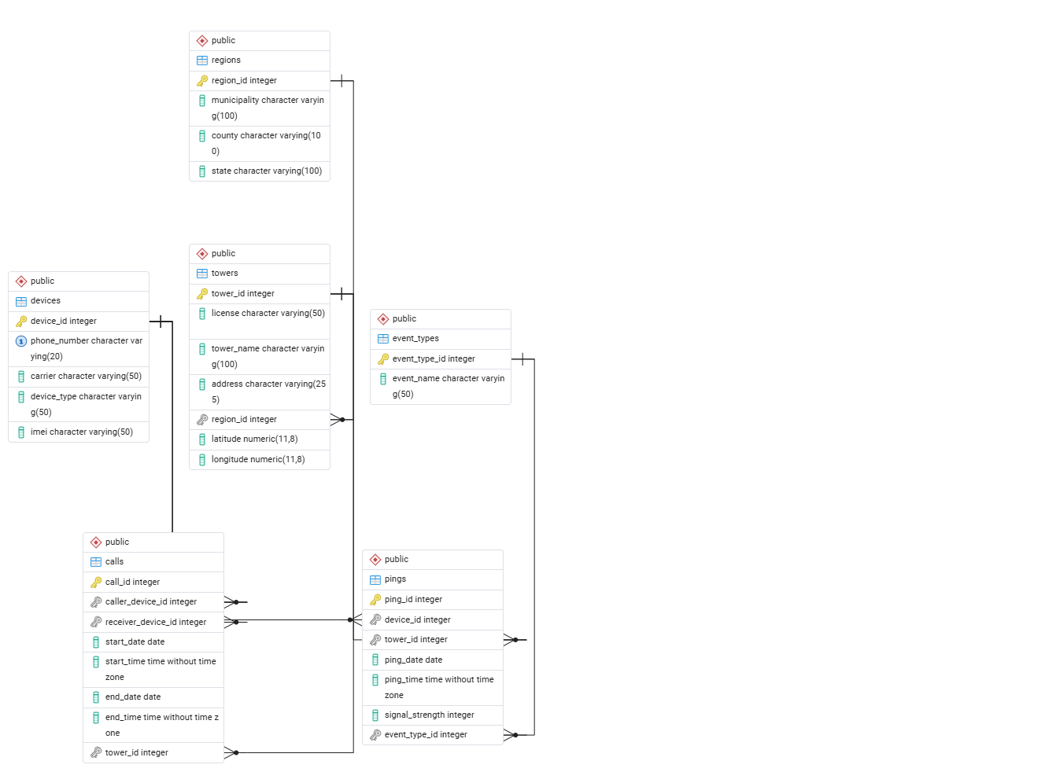

One-to-Many
- Region -> Towers
  - One region has many towers
- Tower -> Pings
  - One tower has many pings
- Tower -> Calls
  - One tower has many calls
- Device -> Pings
  - One device generates many pings
- Device -> Calls (as caller)
  - One device can be the caller to many calls
- Device -> Calls (as receiver)
  - One device can be the receiver to many calls
- Event Types -> Pings
  - One event type applies to many pings

Many-to-One
- Towers -> Region
  - Each tower belongs to one region
- Pings -> Tower
  - Each ping belongs to one tower
- Calls -> Tower
  - Each call references one tower
- Pings -> Device
  - Each ping belongs to one device
- Calls -> Caller Device
  - Each call has exactly one caller device
- Calls -> Receiver Device
  - Each call has exactly one receiver device
- Pings -> Event Type
  - Each ping has exactly one event type

Section 3 – Queries
These queries show how the relationships between the tables and show data in specific ways to accurately understand the data for different scenarios.
The majority of the queries involve WHERE, GROUP BY, ORDER BY, and JOIN.

Comprehension

INSERT
Adds a value to the devices table dataset.

MAX, MIN, AVG
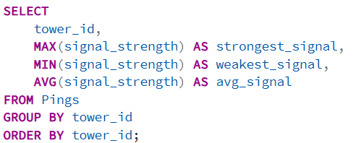
Finds the strongest, weakest, and average signal strength by tower.

HAVING, COUNT()
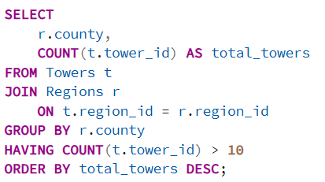
Shows counties with more than 10 towers.

IN Operator
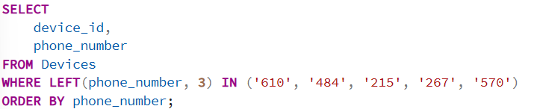
Finds all devices using major PA area codes.

DISTINCT
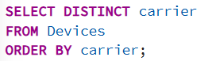
Shows unique carriers in the database.

CONCAT()
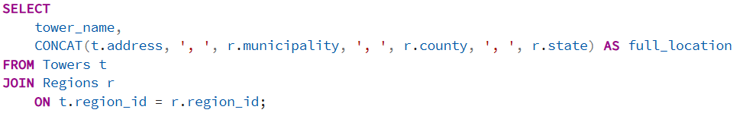
Creates full location display for towers.

DENSE_RANK, Window Function
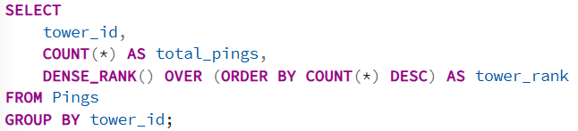
Ranks towers by total pings without skipping rank numbers if there is a tie.

LEFT(), LIKE
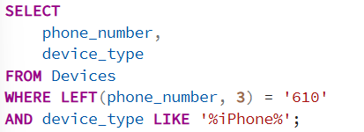
Finds all iPhone users with 610 area code.

CTE
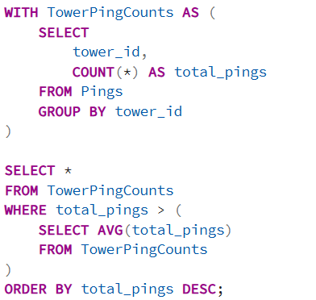
Finds towers with above-average total pings.

Procedure (New Feature)
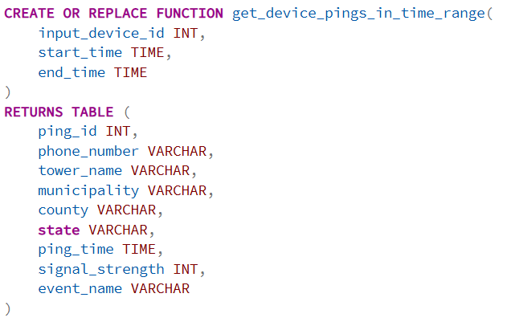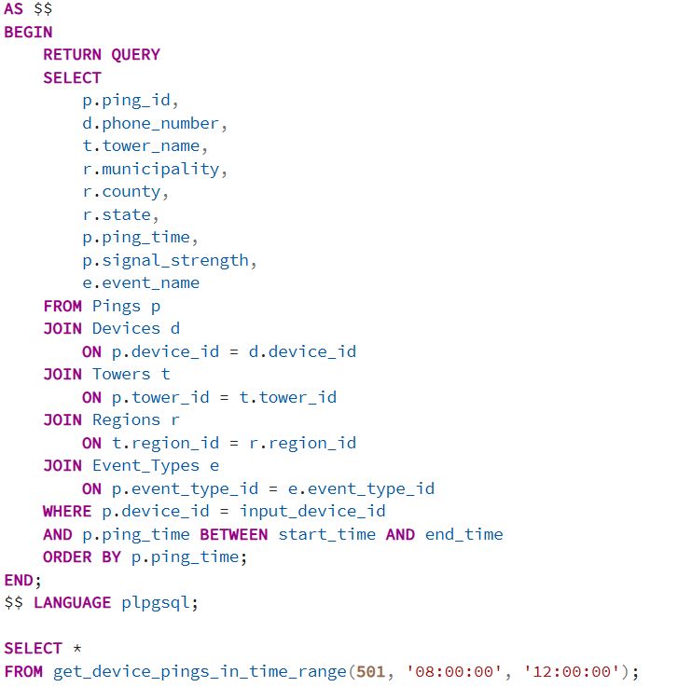
Returns all pings for a given device within a time range.

Project Related Tasks
These queries are tasks that combine many functions and are designed for the database’s intended usage.

Retrieve Ping Activity in a Timeframe (New Feature)
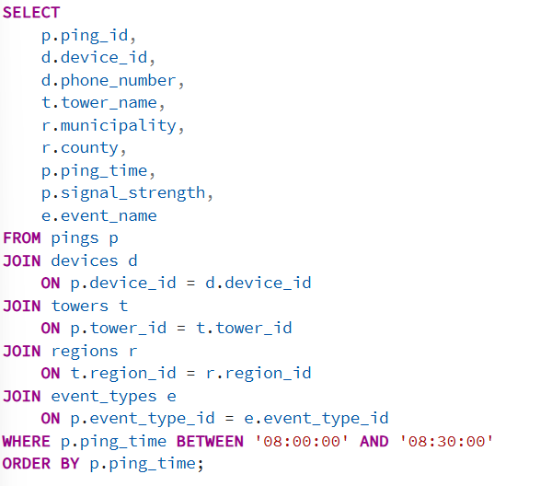
Retrieves all the pings between the times 08:00:00 and 08:30:00 in all of the regions’ towers as well as which devices pinged from the towers. This is a general record of all the pings, only limited by a timeframe.

Identify the Most Frequently Used Towers by Each Device (New Feature)
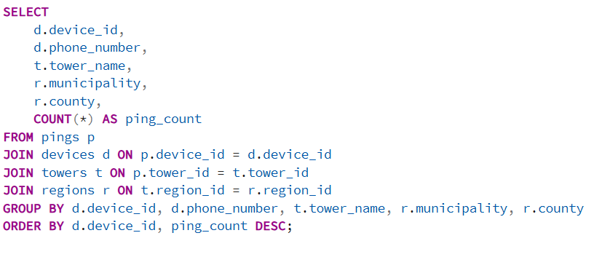
For every device, this reveals which towers they connect to most often, effectively mapping their home area, work area, or movement patterns.

Find All Calls Where Caller and Receiver Were Connected to the Same Tower Region (New Feature)
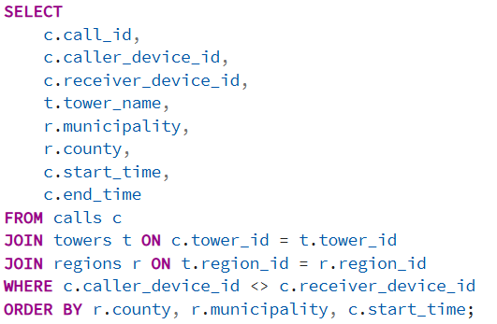
Calls where both parties were in the same geographic region, useful for proximity analysis or identifying local communication clusters.

